## ME 322 Machine Design

## Assignment 6 (Set 1) Submission Date:19/04/22

1. **Derive the expression for dynamic load capacity of ball bearings under varying loads and speeds.**
2. **Explain Abrasive wear and corrosive wear in bearings.**
3. **Write a short note on lubrication of rolling contact bearings.**
4. **Explain the ISO plan for the dimension series of the bearing having bore diameter of 60mm.**
5. **Write the advantages of needle bearings.**
6. **Write the guidelines for selection of lubricants for rolling contact bearings.**
7. **What are the precautions to be taken during the mounting of rolling contact bearings?**
8. What are the different methods used for preloading of cylindrical roller bearings?
9. What is reliability of bearings? Explain its relation with bearing life.
10. Write a short note on selection of tapper roller bearings.
11. A shaft transmitting 50 kW at 125 rpm from gear G1 to gear G2 and mounted on two single row deep groove ball bearings B1 and B2 is shown in the figure below. The gear tooth forces are Pt1 = 16915 N, Pt2 = 9749 N, Pr1 = 5893 N and Pr2 = 3676 N. The diameter of the shaft at bearings B1 and B2 is 75 mm. The load factor is 1.4 and the expected life for 90% of the bearing is 10,000 hr. Select suitable ball bearing.

|  |  |  |
| --- | --- | --- |
| Inner dia. of bearing, d (mm) | Basic load rating, C (N) | Desig-nation |
| 75 | 28600 | 10615 |
| 39700 | 6015 |
| 66300 | 3215 |
| 112000 | 6315 |
| 153000 | 6415 |

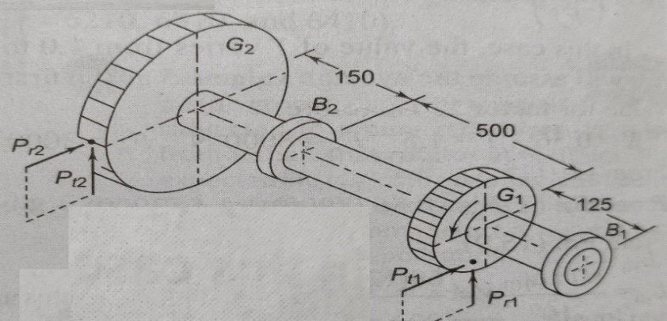

1. In ball bearing, the life of bearings, L in number of revolutions and the radial load, R are related by the expression,RL (1/3)= K, where K is a constant. It withstands a radial load of 3 kN for a life of 720 million revolutions. Find the load for a life of 1 mil revolutions.